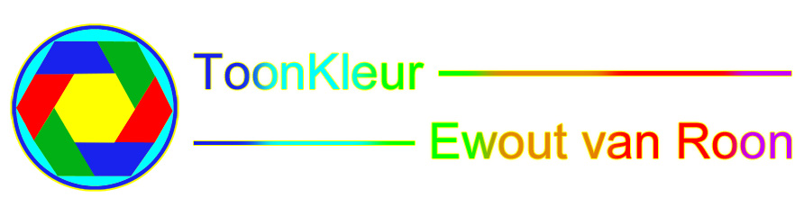
SUMMARY LIST FILMS

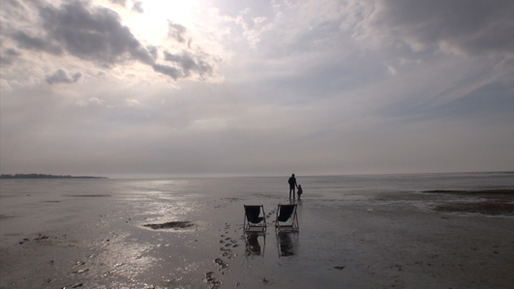
Wad (Mudflat/Beach) 9 min 30 sec. Beautiful misty images, shorebirds and foam, with a frame of colourful bubbles, big ‘ijseieren (ice balls)’ waiting on the tide to take them to the horizon. A father and his daughter walk into the endless skyline.
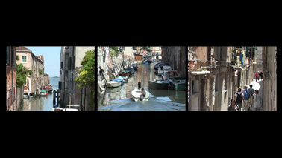
Venetië (Venice) 8 min 4 sec A triptych of the picturesque and water rich city of Venice. Countless stories can be seen from Venician bridges and waterbus stops. Fairytale evening images.

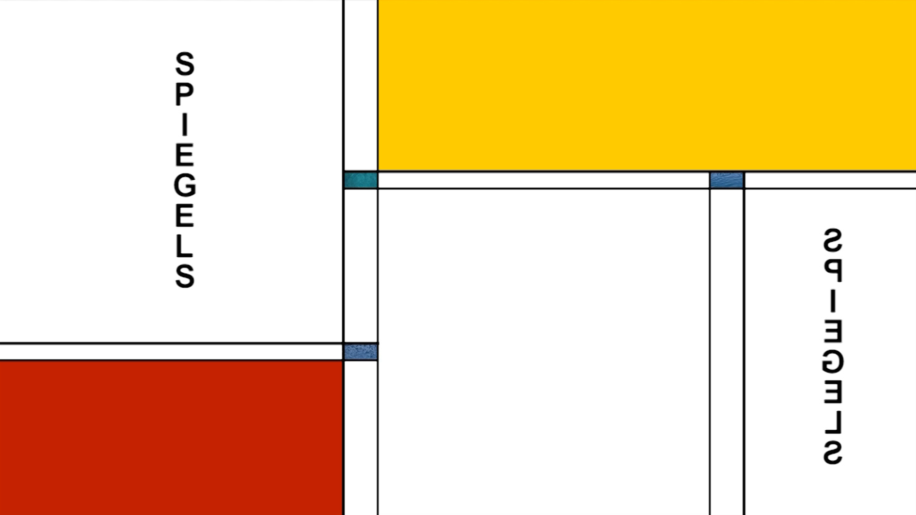
Spiegels (Reflections) 9 min 46 sec Sunny images reflected in water. Reflections of a glass of beer on a terrace in the harbour of Marmaris, reflections of houses on the island of Morano near Venice and people enjoying the spring sun on the Paris Canal.
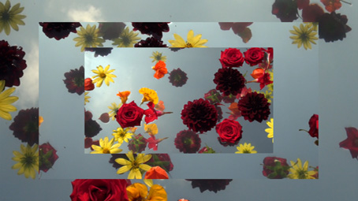
Zweefbloemen (Floating Flowers) 12 min Video artwork of flowers floating on the water. Filmed both during the day and in the evening.

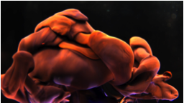
Wervelen (Swirls) 11 min 30 sec A chain of diverse film clips of ink in water which blend together. The images of the film are shown at 10% of the original speed, which allows exciting images to be created and evolve dynamically in the video.

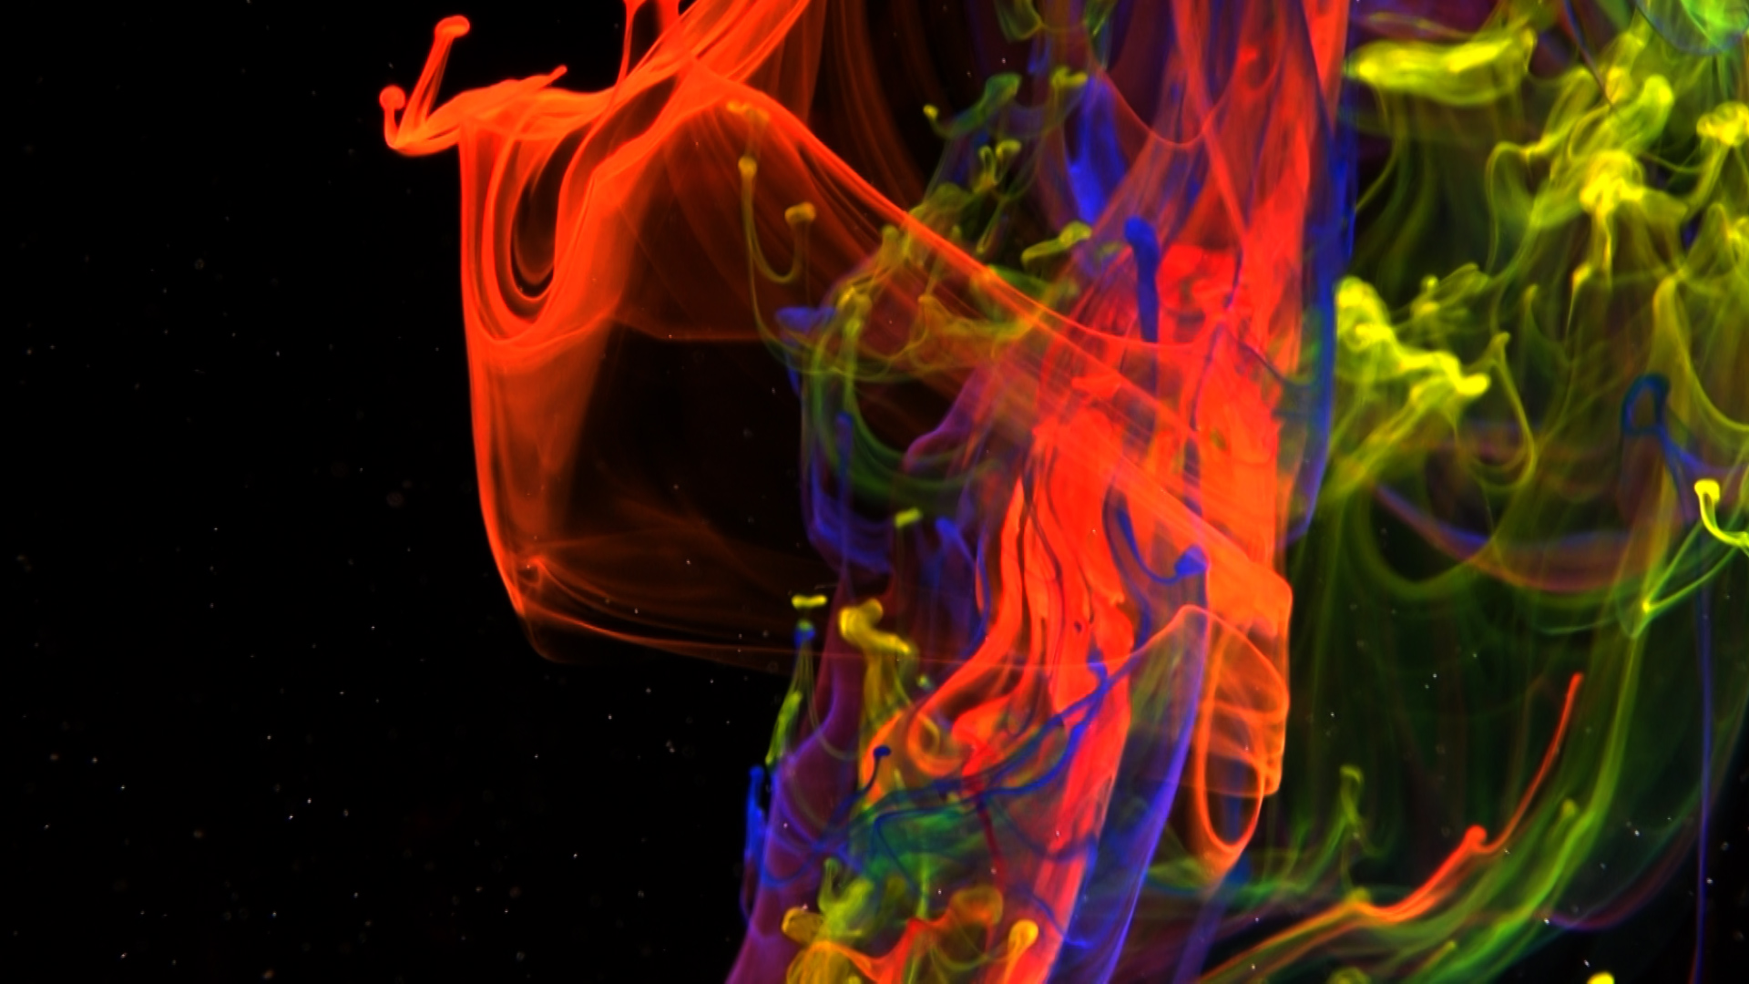
Wonderspiraal (Magical Spiral) 72 min A film clip of ink in water 43 seconds long that has been reworked into a film where the images have been slowed down to 1% of the original speed. The movement is then barely noticable and it looks like an abstract painting.

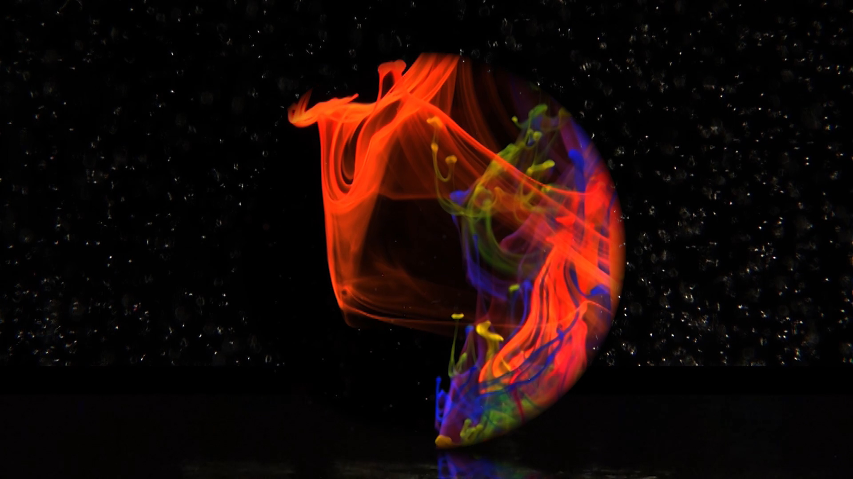
The Miracle of Amsterdam 33 min In ‘The Miracle of Amsterdam’, the ‘Magical Spiral’ is filmed in sphere form in a variety of speeds, directions, and positions, and also mirrored. Positioned in a location where it looks as if the ball drifts on water under the starry sky. The beginning and the end of the film flow into one another as the film is looped.
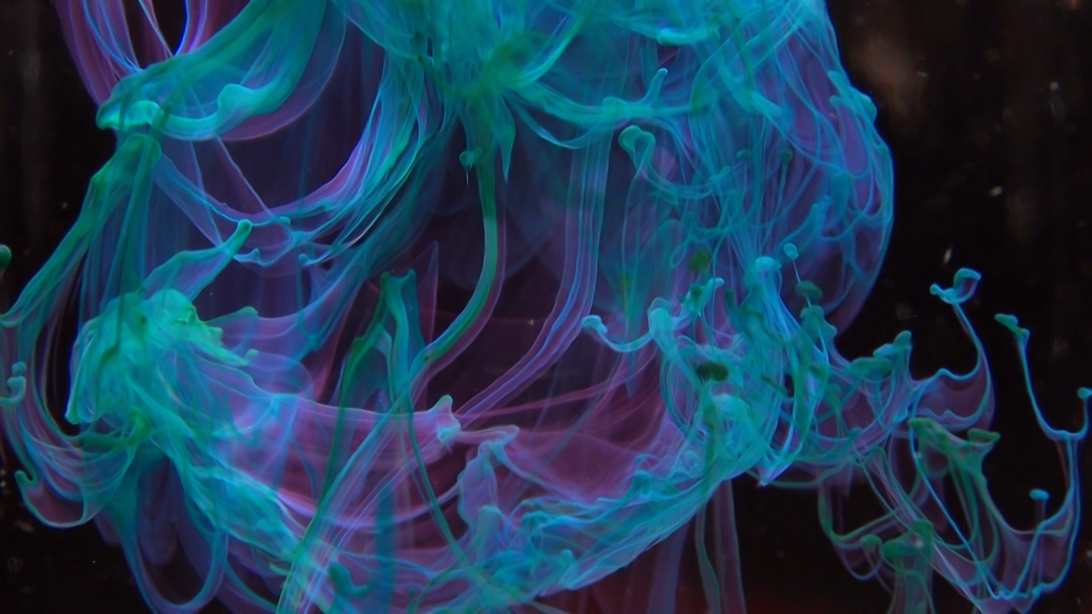
Bennu’s mind 11 min Bennu’s mind changes in speed and is mirrored halfway through so that, after 11 minutes, the end of the film is the same as the beginning. In this way, the film can be played in a loop. The film begins in blue tints which are later dominated by red ink.

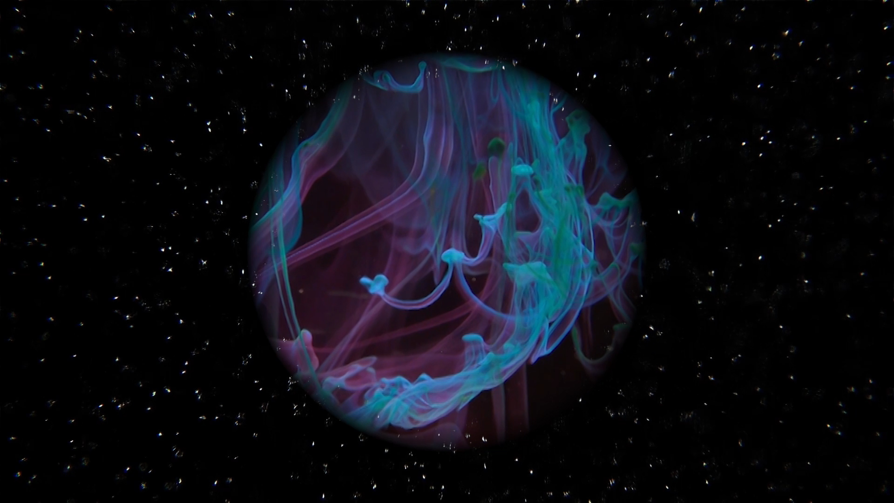
Bennu’s mind in space 22 min ‘Bennu’s mind in space’ is a version of ‘Bennu’s mind’ filmed in sphere form and appearing to float in a starlit sky. Great for viewing on a ceiling.

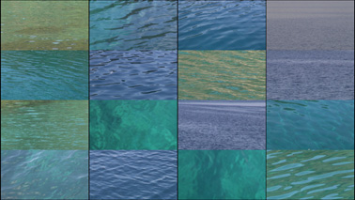
Dag en nacht (Day and Night) 10 min Beautiful mediterranian colours and reflections of sunlight and artificial light on the water. The clips are combined with pauses inbetween filming in the same place, showing how the night changes to day and vice versa.

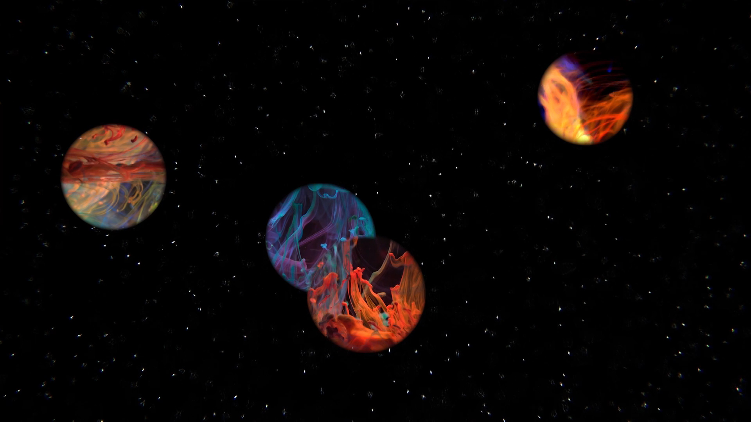
Bennu’s dream 2 min 26 sec ‘Bennu’s dream’ was created in response to a call from NASA to artists to create digital artworks that will go on a spaceship to the asteroid Bennu. The film went into space on 8 sept 2016. This film is also suitable to be shown on a ceiling.

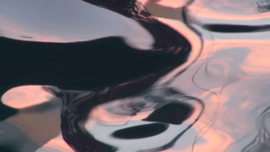
Kringels 12 min The film looks like a slow moving abstract painting, mainly, in black and rose tints. The images are of the water and shadows of ships in the harbour of Marmaris in Turkey. They are close ups which were then slowed down. Through a change in speed and the length of the film each copy can be made unique.
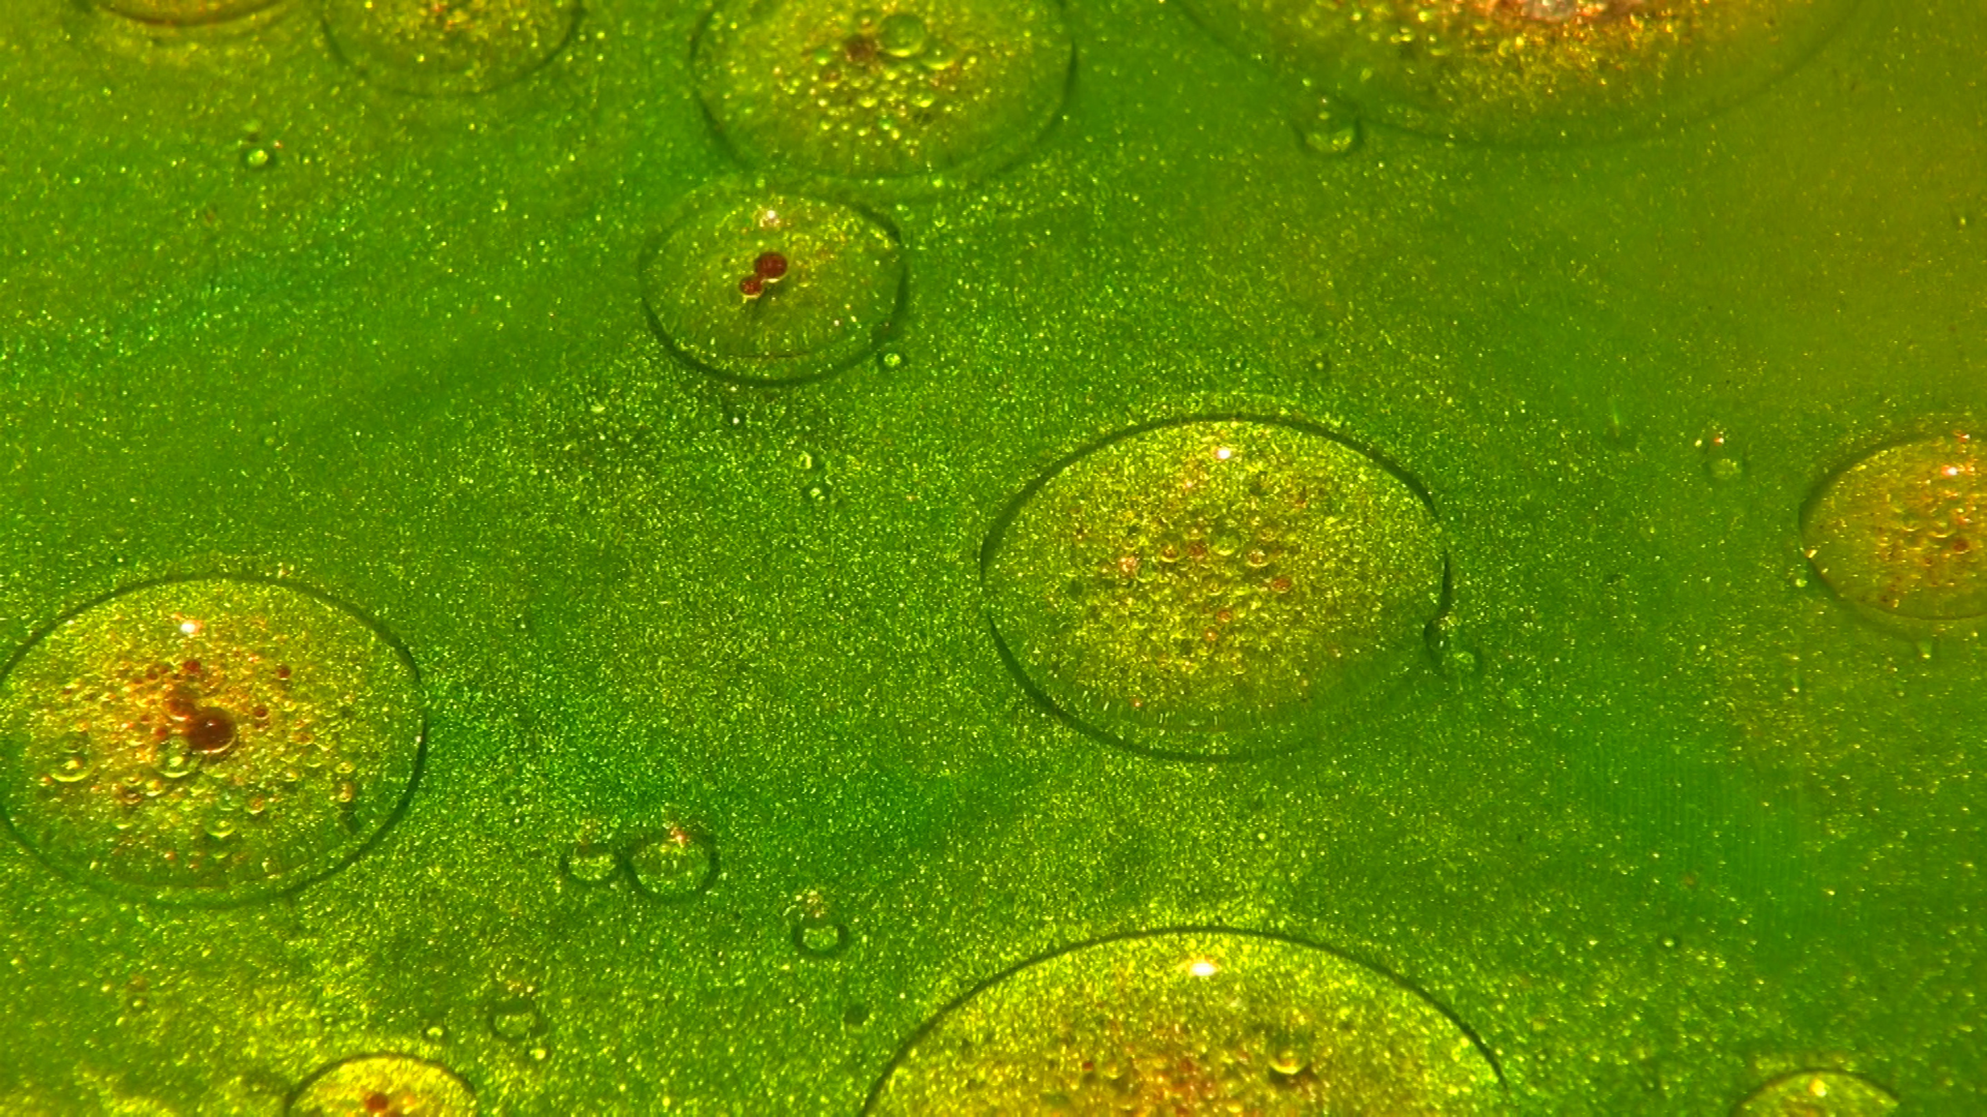
Inkt (Ink) 9 min 12 sec Swirling images of ink which were made using different techniques, including the liquid slides technique popular in the 70s, and a self-designed method that allows ink droplets to drip into the water.

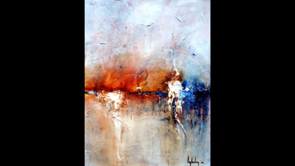
Geschilderd water (Painted water) 46 min 40 sec Photos of 13 paintings by John Ligtenberg, with water as the theme, flow into each other.

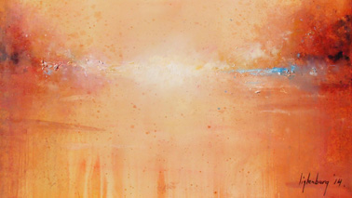
Geboorte van IJsselgezicht (Birth of the Ijsselgezicht) 3 min 30 sec Ewout van Roon filmed the creation of the painting ‘IJsselgezicht’ that was painted by John Ligtenberg.

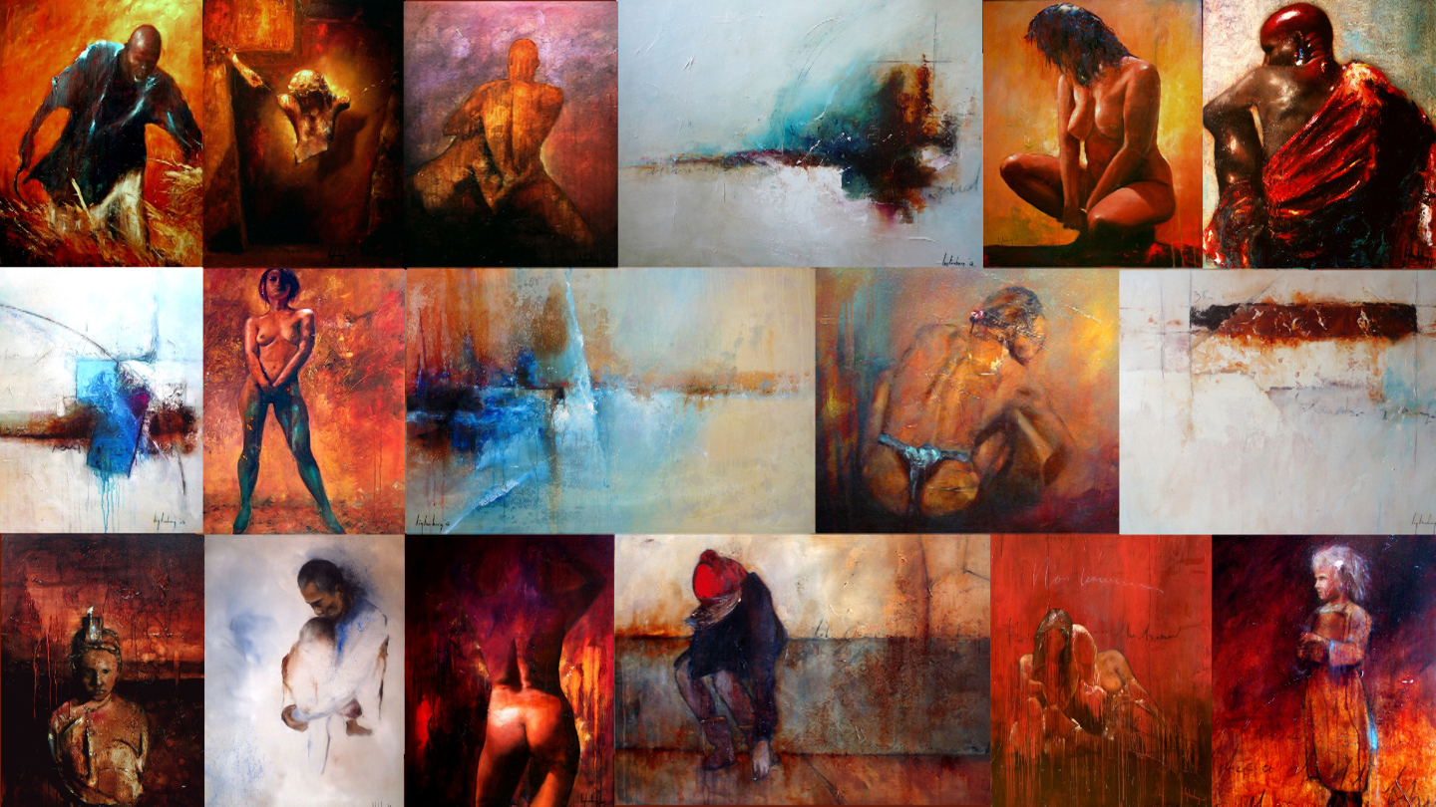
Collage John Ligtenberg extended 21 min 14 sec The collage is made up of 18 photos of paintings and is composed of three parts: ‘Red’, ‘People’s worries’ and ‘New horizons’. The collage is extended with faster versions of ‘Painted water’ and ‘Birth of the Ijsselgezicht’.
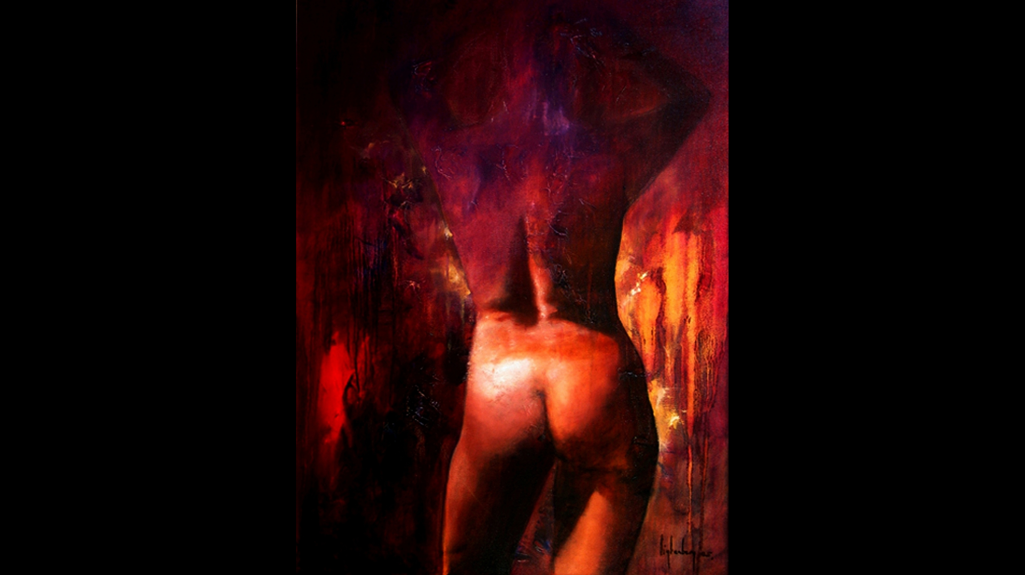

Red 22 min is made up of four photos of red tinted nudes painted by John Ligtenberg. The film is a slower version of the ‘Red’ section from ‘Collage John Ligtenberg’.

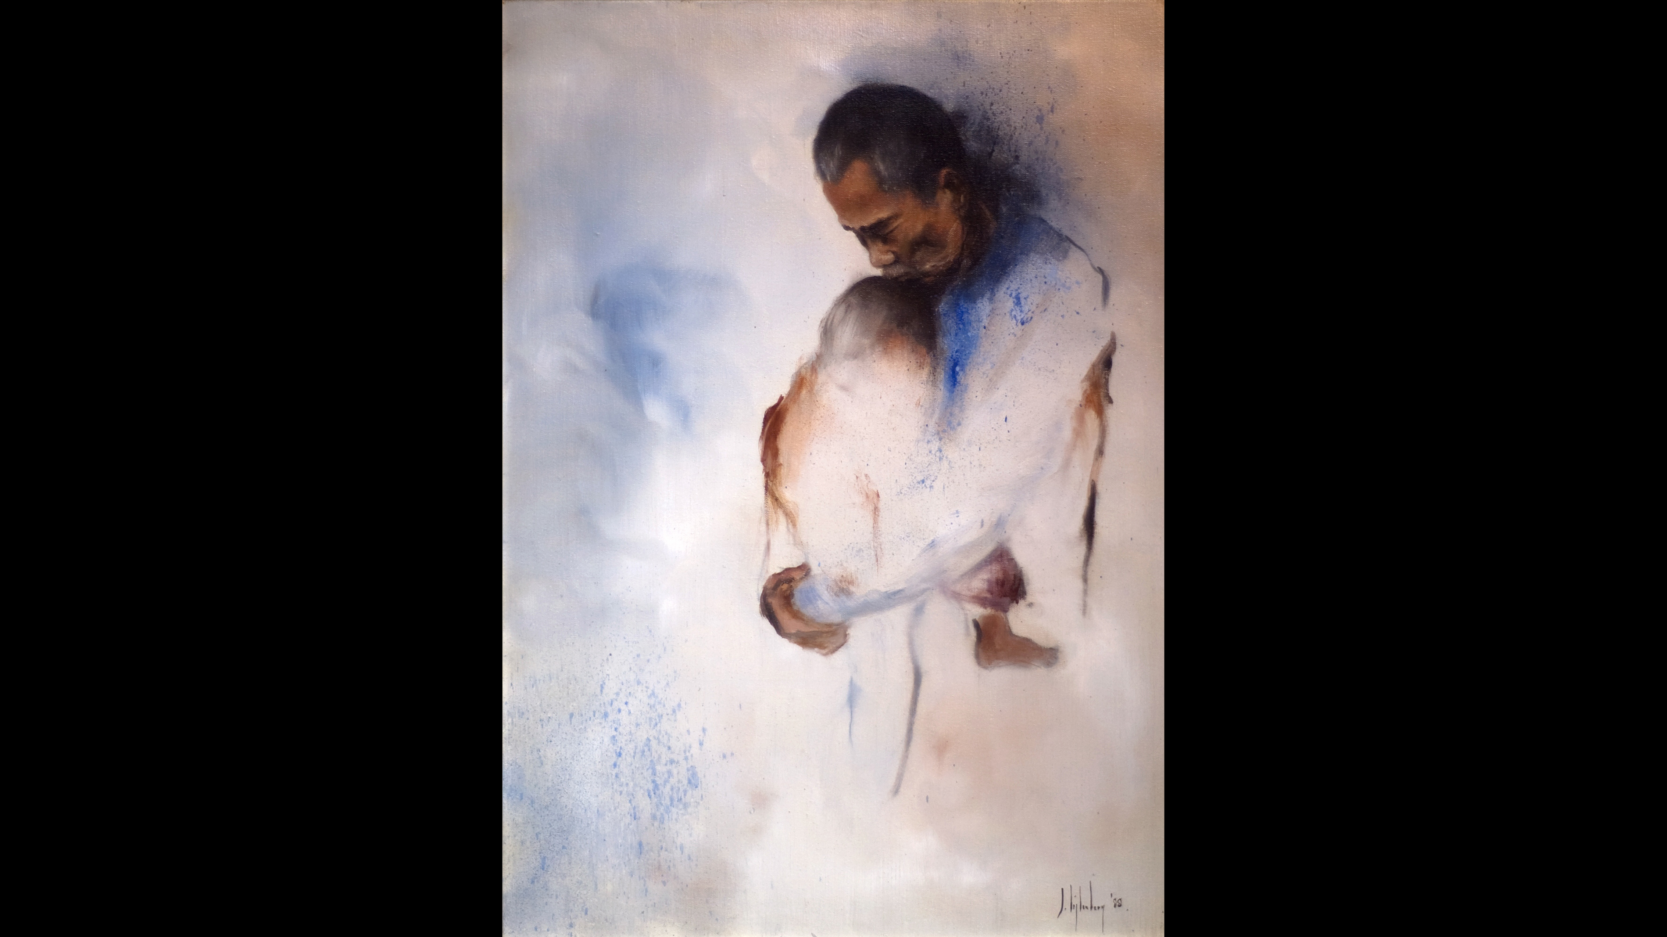
People’s worries 20 min 20 sec Ten photos of paintings of people, painted by John Ligtenberg; a slow motion version of the same film that comprises part of ‘Collage John Ligtenberg’.

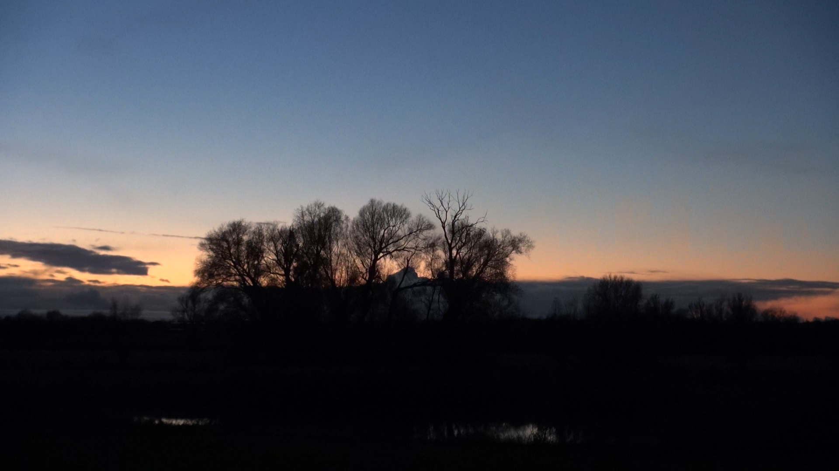
Winters licht 24 min Landscapes in the municipality of Lochem during winters twilight.

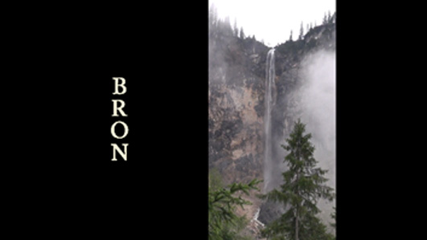
Bron (Source) 8 min 39 sec Water as the source of life. Always circling. Rain falls from the sky, gathers into a waterfall, forms a stream, a river, a lake, the sea and evaporates again. Water makes life possible.

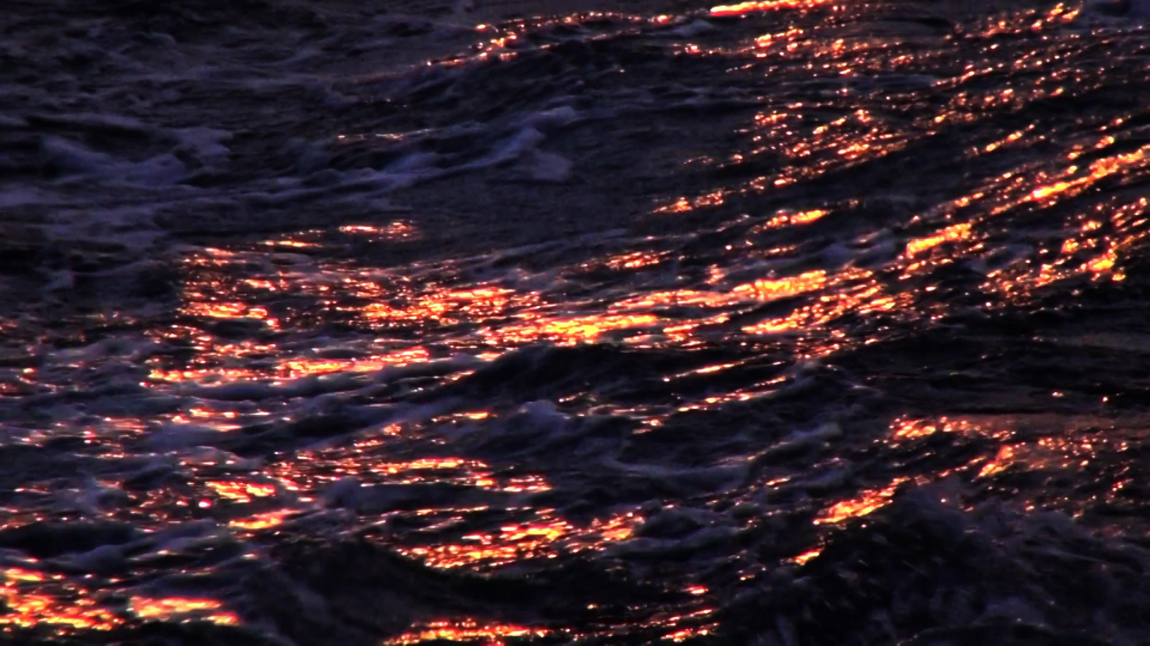
Blauw goud (Blue Gold) 5 min 30 sec Roughly 3 seconds of film of a wave. Filmed in winter light in a Norse fjord near Tromsø. Made darker and slowed to 1% of the original speed. Resulting in ‘blue gold’.

